**PROPERTY MANAGEMENT AND SALESFORCE APPLICATION**

**INTRODUCTION:**

**1.1 OVERVIEW:**

Property management is the daily oversight of residential, commercial, or industrial real estate by a third-party contractor. Generally, property managers take responsibility for day-to-day repairs and ongoing maintenance, security, and upkeep of properties.

**1.2 PURPOSE:**

## 1. Tenant selection

One of the essential advantages of using a property management company is that the property manager will screen all prospective candidates. Since they have seen hundreds of rent applications, experienced property managers are more likely to identify potential red flags when screening candidates. In addition, they know what to look for in great renters and have experience finding them, such as a tenant with a positive rental history, such as paying rent on time, taking care of the property, etc. Allowing them to oversee the tenant screening process might increase your chances of finding a trustworthy tenant.

## 2. The point of contact for renters is a Property Management company

Things break, and sometimes at inconvenient moments. Instead of receiving that call and having to either drive over to the unit to check it or organize a service provider, a property manager handles problems at all hours and often has a long list of reliable service providers to call when something breaks.  
A property management company will also be the point of contact for any maintenance or interior upkeep-related issues.

## 3. Promoting your rental property

Promoting your property and making sure that it attracts the right tenants is tough. Hiring a property management company will ease things for you. Since they continuously work in this business, a property management company is well-versed in what works. In addition, they are familiar with the area and might perhaps advise you straight away on how to set a competitive rent price.

## 4. Happy tenants stay longer

A reputable property management company has a genuine interest in serving your renters just as they serve you as their customer - and they work hard to keep tenants pleased. This is achieved through being attentive and available and resolving problems as they arise. As a result, satisfied tenants are less likely to look for a new house when rents rise (reasonably, of course).

## 5. Rent payments are more likely to be made on schedule

Property management companies are encouraged to ensure that rent payments are on time since their charges are deducted from incoming monthly rents. Consistent collection, including following up on late payments and charging late penalties, can help ensure that maximum rents are paid on time. In addition, a property management company is more inclined to enforce lease terms if payments are not received. Property managers are also knowledgeable and have systems to deal with renters frequently late on rent payments or do not pay their rent.

## 6. Legal Representation

Your property manager manages the tenant relationship and stays in touch with landlord-tenant legislation and fair housing laws. This allows you to prevent any potential legal issues or litigation. In the long term, you will save time, energy, and money when problems with renters emerge and your experienced property manager understands how to overcome them. In addition, property managers understand eviction procedures and how to resolve property damage concerns.

## 7. Spend less money and time on repairs and upkeep

Because regular maintenance and repairs are an important component of a property management company's responsibilities. They usually have strong partnerships and on-staff maintenance assistance for all aspects of property upkeep. Inspections, routine maintenance, emergency repairs, property maintenance when tenants move out, and renovations are all part of this. A property management company knows who to call to have the job done well, at a reasonable rate, and on time, giving you the flexibility not to spend hours looking for a contractor you don't know and don't know the quality of their work.

## 8. Reduce your stress

Hiring a good property management company will relieve you of more stress than you might think. You save time and energy by having a property manager handle your property concerns, such as rent collection, maintenance calls, property turnover, bill and tax payments, accounting, and marketing. Your quality of life is important, and a property manager may be an invaluable resource while you invest in real estate and generate passive income through property rentals.I always hold back the thought of buying a property. But your blog on benefits of using a property management company gave me the power to make the right decision.

**2. Problem Definition & Design Thinking**

**2.1 EMPATHY MAP:**  
  
 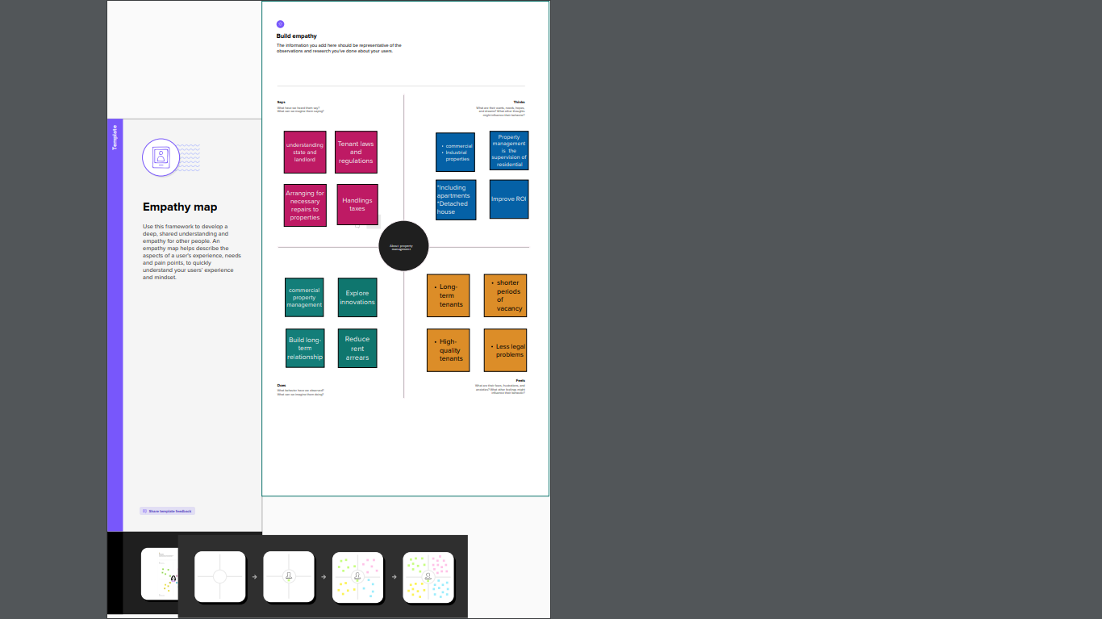

**2.2 Ideation & Brainstorming Map:**

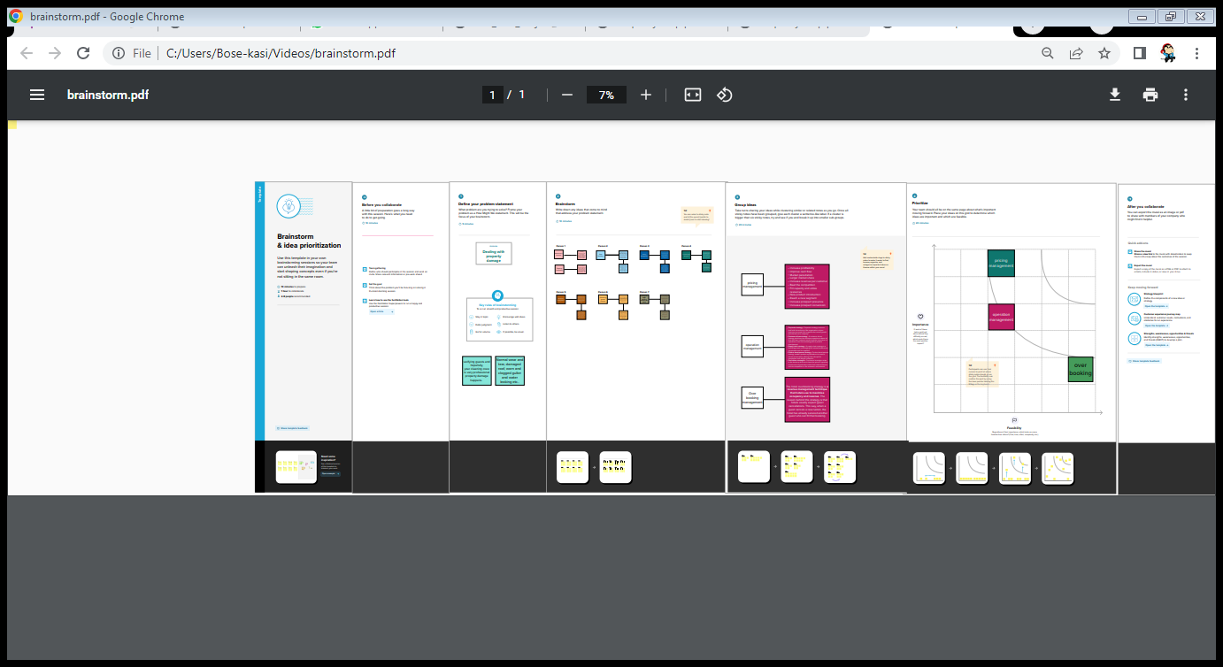

**3.RESULT:**

**3.1 DATA MODEL:**

|  |  |
| --- | --- |
| Object name | Fields in the Object |
| Lead | |  |  | | --- | --- | | Field label | Data type | | Lead | Text | | City | Picklist | | email | Email | | Number field | Auto Number | | phone | Phone | | state | Picklist | |
| **Buy** | |  |  | | --- | --- | | Field label | Data type | | Buy | Text | | City | Picklist | | Discount | Percent | | Property | Picklist | | State | Picklist | |
| Loan | |  |  | | --- | --- | | Field label | Data type | | Loan Id | Auto Number | | Interest Rate | Currency | | Term | Number | | Annual Loan | Number | | Loan Installments | Number | | Loan Repayment | Number | | Loan amount | Formula | |
| Rent | |  |  | | --- | --- | | Field label | Data type | | Rent | Auto Number | | Chennai | Text | | BHK | Picklist | |

**3.2 Activity & Screenshot:**

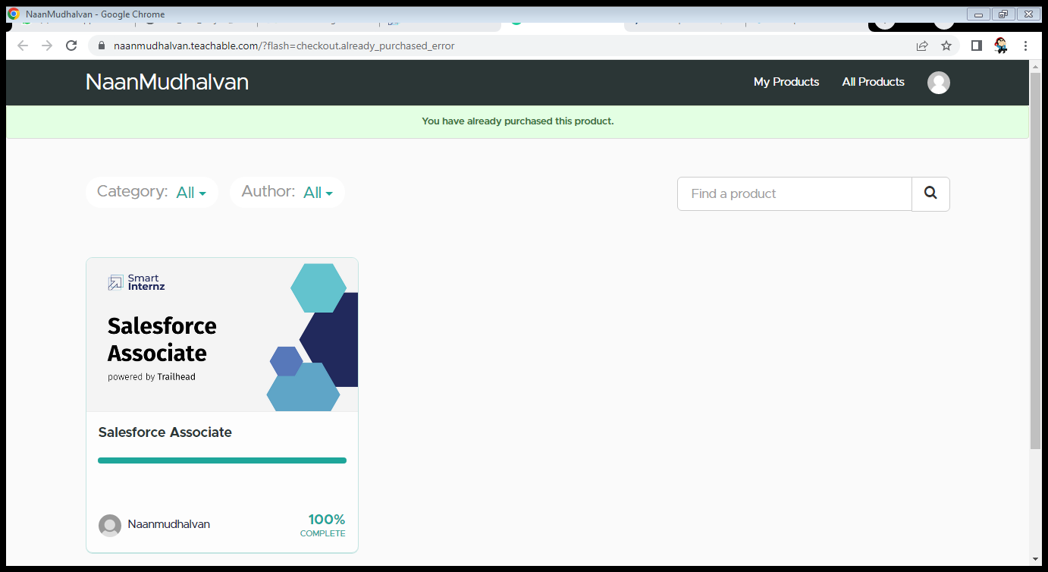

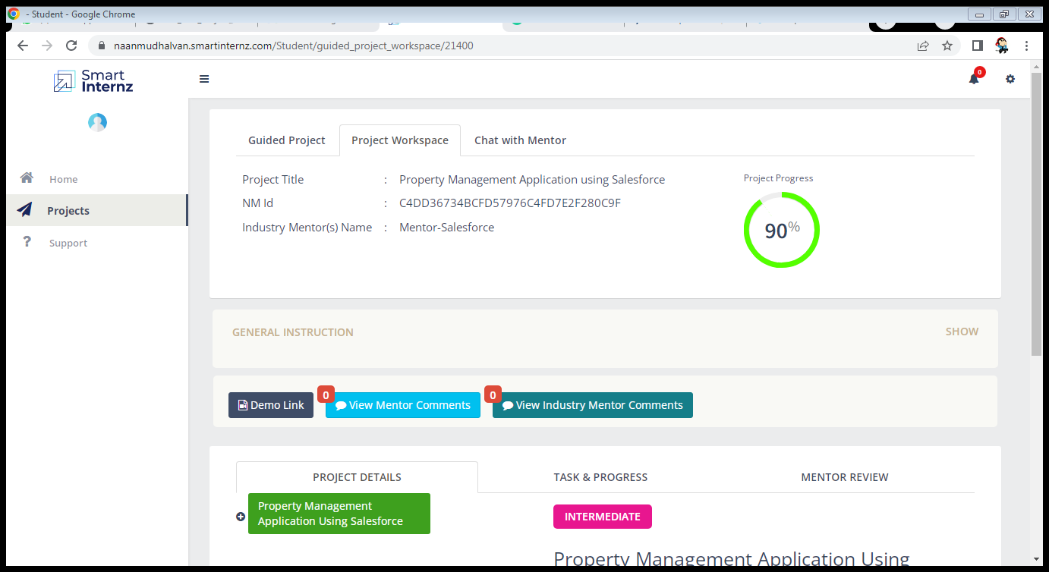

**4.Trailhead profile Public URL:**

**Team Lead-https://trailblazer.me/id/meena2207**

**Team Member 1-https://trailblazer.me/id/dmonica3**

**Team Member 2-https://trailblazer.me/id/kalaivani19**

**Team Member 3-https://trailblazer.me/id/muthu34**

**5.**

**(i) Advantages :**

### You can access your information from anywhere

A major advantage of a property management system in a hotel is having access to all of your information in one place, whether you’re onsite, at home or out of town. Because many property management systems operate via the cloud, you’ll have access to your information through all your devices. From a computer, tablet or smartphone, you’ll be able to pull up information in real-time, including inventory, revenue, personnel information, accounts payable and receivable and more.

### You’ll save time and money by being more efficient

The number one job of an employee in the hospitality industry is to provide excellent customer service to guests. When employees spend hours on routine tasks such as reservation management, scheduling, housekeeping assignments, maintenance requests and other manual administrative tasks, guest services can suffer.

### You’ll increase bookings by refining your online presence

While the face of your hotel may be your frontline staff, your guests’ first impression of your property is often what they see and read online. One of the most effective benefits of a property management system in a hotel is the ability to integrate the software with your existing website. Services such as a direct booking engine, a 24-hour chat assistant or online concierge services add value to the guest experience from the first point of contact. Automating these tasks also means your employees are spending time taking care of guests.

### You can optimize your revenue stream using built-in pricing tools

Most hotels change rates twice per year – peak occupancy season and low season. While it may be less time-consuming, you’re also missing out on a lot of revenue. Selecting a property management system with built-in pricing tools can increase your revenue by allowing you to set several rate options, including weekend fluctuations, special event pricing, promotional offers, package rates, valued customer deals and group sales options.

**(ii) Disadvantages:**

### You’ll be dependent on one vendor

Property management systems allow you to connect every aspect of your business through one application. However, this may make it more difficult to use other third-party products that may be more useful to your business, such as payroll or accounting programs.

### Cost can be prohibitive in the beginning

If you’re a small, family-owned business in a non-tourist destination, it can be difficult to come up with the cash for an all-in-one property management system right away. Over time, these solutions pay for themselves in saved time and increased bookings, but you’ll want to make sure you choose the right product for your type of business.

Because the software is often proprietary and may not accept or play well with other tech products, you may be forced to abandon your property management system if it doesn’t work for you, or spend more money to find a more appropriate solution.

## Partnering with Stasher.com can increase revenue

As you consider your purchase, it is possible to offset the cost of the software using a tool you already have at your disposal – extra space. Stasher.com is creating partnerships with hotels and short-term renters in any location to offer unused space in exchange for monthly payments.

**6.APPLICCATION:**

A property management system (PMS) is a software application for the operations of hospitality accommodations and commercial residential rental properties. PMS is also used in manufacturing industries, local government and manufacturing. A property management system is sometimes referred to as a hotel operating system or hotel OS.

Functions managed by a PMS include automation of many common tasks, including:

* Bookings
* Check-in and check-out
* Telephone systems integration
* Point of sale (POS) integration
* Event planning
* Food and beverage costing
* Security and room locks

### 7. Conclusion:

|  |
| --- |
| In conclusion, Property Management System (PMS) software is very crucial for all the Hotels. Especially Opera PMS constitutes the most appropriate PMS software for Hilton Athens. It is user friendly, connects with Central Reservation System (CRS), Point of Sale (POS) etc. and provides all the tools the hotel needs in order to operate effectively. The disadvantages of the Opera PMS can be improved easily and as it was mentioned before a recommendation is the upgrade of Opera V5 to Opera 9. |

**8. THE FUTURE PROPERTY MANAGEMENT:**

### ****IOT and smart home technology:****

The emergence of the Internet of Things (IOT) and smart building technology has forever altered the landscape of property management. IOT involves the interconnection between numerous physical devices, allowing for data exchange across all connected elements. Furthermore, smart building technology offers homeowners a convenient way to control their appliances and systems from afar. These twin technologies are revolutionizing how properties can be managed with remarkable efficiency.

### ****Artificial intelligence (AI):****

Property managers can significantly benefit from the use of AI-driven tools, allowing them to make data-supported decisions regarding pricing and marketing strategies, maintenance operations, and more. By utilizing Artificial Intelligence in property management projects, costs are minimized while efficiency is increased – both of which contribute toward customer satisfaction. Additionally, mundane tasks such as rent collection or tenant screening can be automated with AI technology which further liberates time for professionals to focus on higher-level strategic endeavors.